THEME 1: PEACE AND SECURITY
LESSON ONE
People who keep peace and security
a) At school
1. Guards
2. Teachers
3. Administrators
4. Children
5. None teaching staff
b) At home
1. Parents i.e. father or mother
2. Guards
3. Maids
4. Children
c) In the community
1. The police 4. The L.Cs
2. The soldier 5. The religious leaders
3. The guards
Name these peace and security keeping people
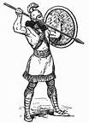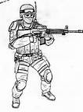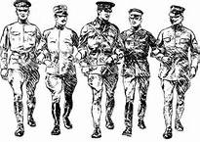 | 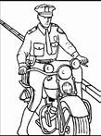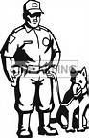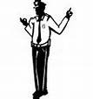
Soldiers | Police officers
Activity
- Mention two people who provide security.
- Move around school to see the security guards.

LESSON TWO
Roles of the people who keep peace and security
- The parents
- They provide security in their homes i.e.
a) By hiring guards
b) By putting fences around their homes.
c) By guiding their children.
d) By reporting wrong doers to the police.
- They provide basic needs. E.g. food, water, clothes, shelter
Draw, name and colour these basic needs
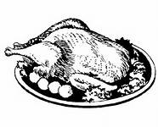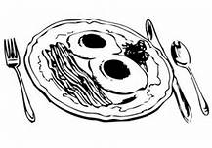  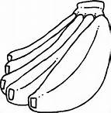 | 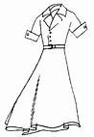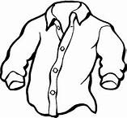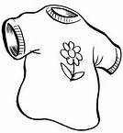 | 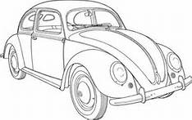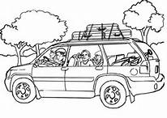  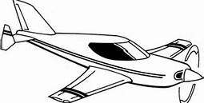
food | Clothes | transport
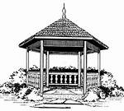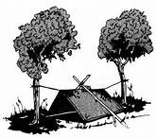  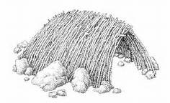 | 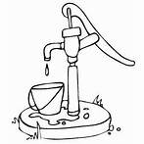  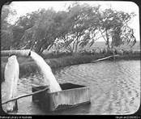 | 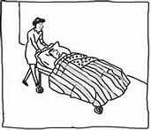  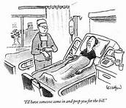
shelter | Water | Medical care
b) Teacher
- They help the children use the school rules and regulations.
Examples of school rules
- Put on proper school uniform.
- No fighting at school.
- No using abusive language.
- Bring to school only what’s necessary e.g. toys are not allowed
- Follow the school timings.
- They guide and talk to the children about their security.
- They guard children against bad people.
On assembly children are counselled and guided against bad people.
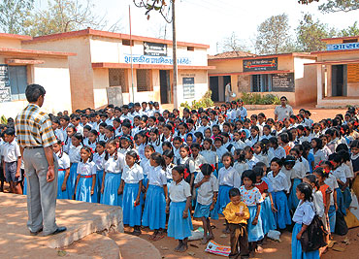
c) Children
- They obey rules and regulations.
- Listen to the teachers’/ parents’ instructions.
- Report strange people and things.
- Respect the school and home property.
d) Policewomen / men
- Keep law and order. – They control traffic on the road.
- Protect people and their property. – They put out fire.
- Arrest bad people. Or wrong doers. – They investigate crimes.
- Provide guidance and counseling.
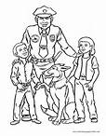 | 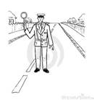
Protecting people | Officer on duty | Fire fighting

What is happening in the pictures above?
e) Religious leaders
- Preach the word of God to the people.
- Provide guidance and counseling.
- Encourage people to live in harmony.
- Pray for the people and the country.
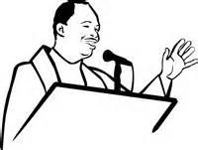 | 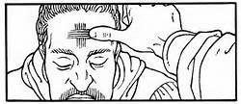
Preaching | Praying for people

LESSON THREE
Ways of promoting peace and security
- Counseling and guidance.
- Following rules and regulations.
- Listening and obeying instructions.
- Practicing religious norms.
- Praying for yourself and others.
- Forgiving people who have hurt you.

Sharing with others
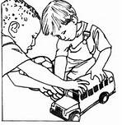 | 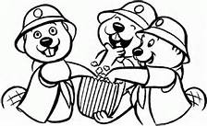

Why is it good to keep peace and security.
- For safety. - For respecting each other.
- Free movement of people, their goods and services.
- For freedom of speech.
- To carry out trade well.
- To protect people’s property.
- For Cooperation
- For love

What happens if there is no security
- People can die.
- There is hunger. - People will be homeless.
- There will be loss of property. – There will be child abuse.
- Movement will be difficult for people and their goods.
A building destroyed during war.
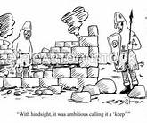 | 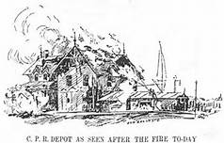 | 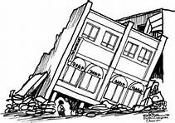

Things we can use to keep peace and security
- Dogs
- Cameras
- Cats
- Parrots
Lesson four
TOPICAL QUESTIONS
1. Write down any two people who keep peace and security.
a) At home a) parents b) maids
b) At school a) teachers b) guards
2. How useful are these people under peace and security in a community.
a) Reverend; preaches the word of God.
b) Soldiers; to keep peace and security in the country.
c) L.C chairman; to keep peace and security in the village.
3. Draw and name any two ways of keeping the security of a home.
Lesson five
THEME: CHILD PROTECTION
Is to keep children safe from dangers
Ways of child protection.
- Bad people should be reported to police.
- Guidance and counseling lesson should be given to children.
- Educate the children about their rights.
- Children should report to their parents the bad things done to them.
- Children should make an alarm for help.
- Children should be encouraged to move in groups.
- Avoid dark corners.
- Children should be taken for education.
How can children protect themselves?
SUB THEME: CHILD ABUSE
What is child abuse?
This is a way children are mistreated by an adult.
People who can mistreat/ abuse children

- Parents Drug users
- Witch doctors
- Teachers
- Strangers

- Relatives e.g. older brothers and sisters. Aunties Uncles, grandparents
Activity
- What is child protection?
- How do we call the way children are mistreated by adults?
Lesson six
Forms of child abuse
- Child labour. – Bad language
- Denial of basic needs - Beating the child
- Child sacrifice. - Burning the child.
- Child neglect. - Threatening the child.
- Child abduction / kidnapping. - Harassing the child.
Name these forms of child abuse.
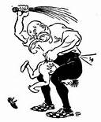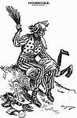 | 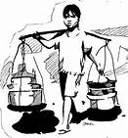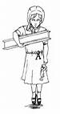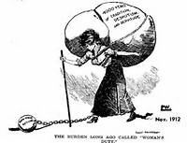
Beating a child | Child labour
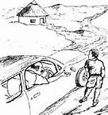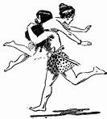 | 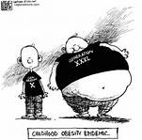
Kidnapping | Denying a child food

Lesson seven
Effects/results of child abuse
What happens if there is child abuse in the society / family/ community?
- Death - pain
- Hunger - Shame
- Fear - Hatred
- School dropouts - Sadness
- disability
- Loneliness -
One can be kidnapped while moving in lonely places.

Lesson eight
TOPICAL QUESTIONS
1. Write down any four forms of child abuse.
1. Burning children 2. Harassing children
3. Denying children food 4. Beating children
2. Who are the people most likely to do child abuse?
1. Parents 2. Teachers
3. Maids 4. Relatives
3. What is child abuse?
Is away children are mistreated by adults.
4. What can children do when one wants to kidnap them?
By making an alarm / running away / reporting to an adult.
5. List down 4 things which may happen if there is child abuse.
1. Death 2. School dropout
3. Fear 4. Hatred

Lesson nine
SUB THEME: MEASURES
Weather
What is weather?
Weather is the state of atmosphere of a place for a short period of time.
Elements/ factors / components/ aspects of weather
- Rainfall - wind - Temperature
- Sunshine - cloud cover

Name these types /conditions of weather
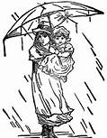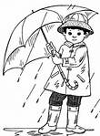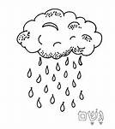 | 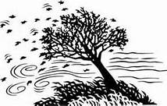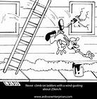
Rainfall | Wind
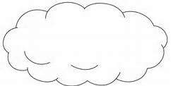 | 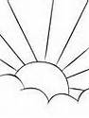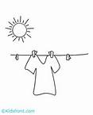
Cloud | Sunshine

Types of weather

- Rainy weather
- Sunny weather
- Cloudy weather
- Windy weather

Lesson ten
SUB THEME: Time
Telling the time of the day
7:00 am, 5:00 pm, 1:00 pm
a) The days of the week

- Sunday - Monday
- Tuesday - Wednesday
- Thursday - Friday
- Saturday

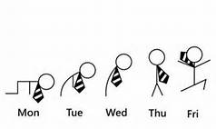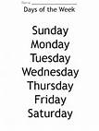
b) What is the last day of the week?
Saturday is the last day of the week.
ii) Which day of the week comes after Tuesday?
Wednesday comes after Tuesday.
iii) Sunday is the first day of the week.
iv) On which two days don’t we come to school?
- Saturday b ) Sunday
v) Write in full.
a) Sun. - Sunday
b) Wed. - Wednesday
c) Sat. – Saturday
lesson eleven
The calendar
1. There are twelve months in a year.
2. A common year has 365 days.
3. A leap year has 366 days.
4. A leap year comes everyafter 4 years.
5. It becomes a leap year when February has 29 days instead of 28days.
(Teacher and the learners try to count the last and next leap year)
Months Days
1. January 31 days
2. February _______
3. March _______
4. April _______
5. May _______
6. June _______
7. July 31 days
8. August _______
9. September 30 days
10. October _______
11. November _______
12. December _______
(Tr. will teach the children how to count the days and month of the year on their hands.)
1. What is the fifth month of the year?
May
2. Which month has the fewest days?
February
3. December is the last month of the year.
4. Name any two months with 31 days.
January / March / May/ July / August / October / December
Lesson twelve
Important events in the year
Event Date
1. New year’s day 1st Jan
2. Liberation day 26th Jan
3. Women’s day 8th March
4. Good Friday March / April
5. Easter day “
6. Easter Monday “
7. Labour day 1st May
8. Martyrs day 3rd June
9. Heroes’ day 9th June
10. Independence day 9th October
11. Christmas day 25th December
12. Boxing day 26th December
Christmas day celebrations
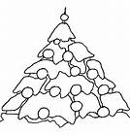 | 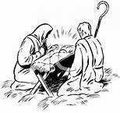 | 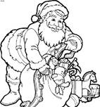 | 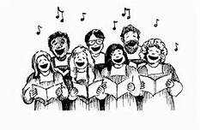
Activity
- What do we remember on these days as we celebrate them;
- Good Friday
- Easter Sunday
- Martyrs day
- Christmas day
- Heroes day
Lesson thirteen
SUB THEME; Seasons
We have two seasons
1. Wet season
2. Dry season
Activities done in the wet season
- Planting - Weeding
- Pruning - Thinning - Transplanting
a) What is planting?
Planting is the putting of seeds in the ground.
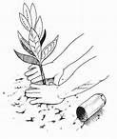 | 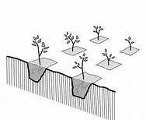 | 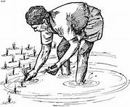 | 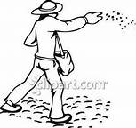

b) What is weeding?
Weeding is the removal of unwanted plants from the garden.
N.B: Unwanted plants are called weeds.
People weeding the garden
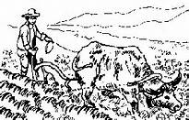 | 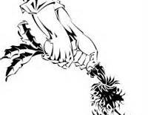
Weeding using an ox | Uprooting the weed

Wanted plants in the garden are called crops.
c) What is pruning?
Pruning is the cutting off of unwanted branches and old parts of a plant.
Someone pruning the crops
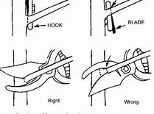 | 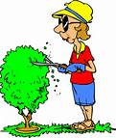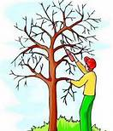
Pruning | Pruning
d) What is thinning?
Thinning is the removal of some plants to give space to the others to grow well.
Someone thinning the crops
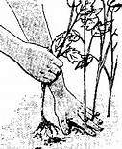 | 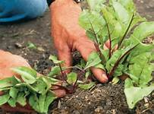 | 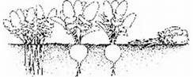
Thinning the crops |  | Non thinned and a thinned area in the garden

Lesson fourteen
e) What is transplanting?
This is the transfer of seedling from the nursery bed to the main garden.
A nursery bed is a small piece of land where tiny seeds are first planted . e.g cabbage seeds.
Someone transplanting crops
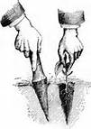 | 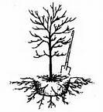 | 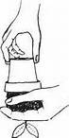
Transplanting
The dry season
Activities done in the dry season
- Watering plants - Drying seeds
- Sheltering crops - Harvesting
- clearing land
f) What is harvesting?
This is the removal of ready crops from the garden.
Someone harvesting
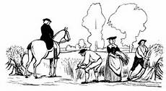 | 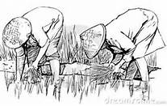 | 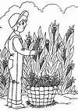
Harvesting
g) What is watering plants?
- This is the way of adding more water to the soil in a dry season.
- This is the spraying of water onto the plants during the dry season.

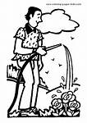 | 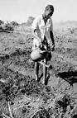 | 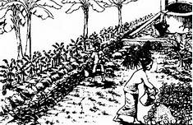 | 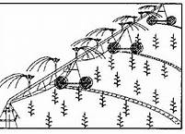
c) Drying seeds
This is when seeds are put out under sunshine to dry.
Drying seeds
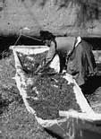 | 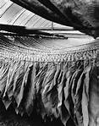 | 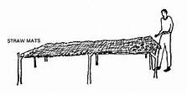 | 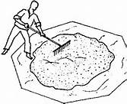
Drying seeds | Curing tobacco | Drying on rack | Drying seeds too on a mat

d) Sheltering crops
This is when you cover top of a nursery bed to protect the seedling from bad weather, animals/pests.
Sheltering crops
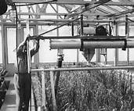 | 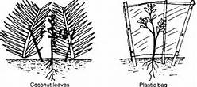
e) Winnowing
The removal of husks from the seeds using wind

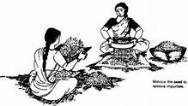 | 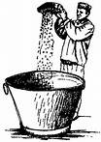 | 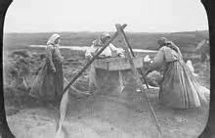

Lesson fifteen and sixteen
Practical lesson
Planting, watering, sheltering, thinning

Lesson seventeen
TOPICAL QUESTIONS
1. Name any two activities done in the wet season.
Ploughing / planting / weeding / thinning /pruning /transplanting
2. What are weeds?
Weeds are unwanted plants in the garden.
3. Transplanting is the transfer of seedlings from a nursery bed to the main garden.
4. What is a nursery bed?
Is a small piece of land where tiny seeds are first planted?
5. List down any three activities in the dry season.
1. Harvesting 2. Drying seeds
3. Watering plants
6. Why are plants sheltered?
To prevent direct sunshine
7. Why do we water plants?
To keep them healthy
MID TERM EXAMINATIONS

Lesson eighteen
SUB THEME: Height
What is height?
Height is how tall or short something is.
Height is measured in metres and centimetres.
Examples of things we measure in height
- People _ Plants
- Buildings _ Mountains
- Hills
- Furniture e.g. tables, chairs, doors

Things we use to measure height
- Thread - Rulers
- Sticks - Strings
- Rolls - Metre rulers

Lesson nineteen
Practical lesson
Measuring heights of things in the class
e.g tables, chairs, the students, teachers
Make records of the things measured
a) I am __________________ metre and ____________cm.
b) The tallest student is ________________ m __________________cm.
c) The shortest student is _________________ m ___________________ cm.
d) My table is ____________m ________________cm.
e) My chair is __________________m _________________cm.
f) Tr .______________ is __________________m and _________________cm.
g) Tr. ______________ is __________________m and _________________cm.
lesson twenty
THEME: Recreation, festival and holidays
Sub theme: Recreation
What is recreation?
Recreation is the way of spending ones leisure (free) time.
Recreation makes our mind and body relax.
Recreation activities at home
- Playing games _ Watching TV.
- Reading news / story books. _ Listening or telling stories.
- Swimming. _ Listening to music.
- Partying / going for picnic. _ Playing computer games.
Some children like playing games.
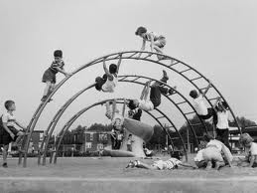 | 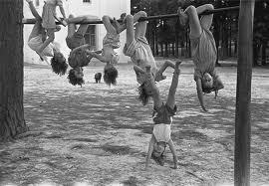

Recreation activities at school
- Resting - Listening to music
- Trips - Watching videos
- Playing computer games - Swimming
- Playing games - Reading story books.
- Dancing
Dancing is liked and enjoyed by many children.
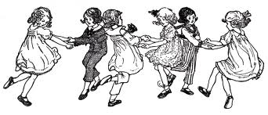 | 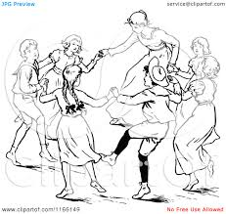
Draw yourself doing one recreation activity

Places where people can go to relax their mind
- Beaches - Theatre
- Gym - stadium
- Game parks - Cinema halls
- Zoo - Field / play ground
- Swimming pools
- Recreation centres e.g Kiwatule, Wonder world, Kavumba etc……
Importance of recreation
Why do we go for recreation?
- To rest - To exercise
- To entertain - For enjoyment
- For fun - For good health
SUB THEME: Festivals
Cultural festivals
What are cultural festivals?
These are celebrations different tribes do in their cultures.
Common cultural practices in our societies
- Naming of newly born children. - Marriage.
- Introduction. - Birth of twins.
- Funeral rites - Initiation
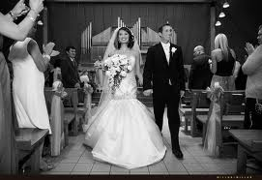 | 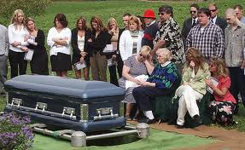 | 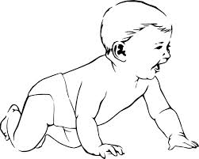
wedding | burial | baby
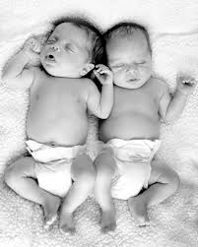
twins

- Naming children
- They can name according to situation.
- They can name according to the position in the family.
Name Tribe meaning
Mugeni Samya Fish
Musoke Baganda Rain
Natukunda Banyankole He loves us
Wasswa Baganda Elder twin
Kato Baganda Young twin
Kizza Bagannda Follower of twins
Kalugyendo Banyankole Born on the way
Mukama Basoga Small gods
Kafuko Basoga Following dead children
What is the meaning of your name?
…………………………………………………………………………………………………………..
SUB THEME : Initiation
Initiation is being allowed to become a member of a tribe / family.
Initiation practices
Practices Tribe
- Circumcision - Bagisu
- De-toothing - Alur
- Naming twins - All tribes
- Tattooing - Karamajong
Why do tribes initiate?

a) For recognition
b) For identification

Sub Theme: Holidays
A holiday is time when people are off their work.
Types of holidays
a) School holidays
b) National holidays / public holidays
c) Religious holidays.
1) School holidays
a) First term holiday c) 3rd term holiday
b) 2nd term holiday
2) National / public holidays
These are given by the government to the whole country.
a) Liberation day - 26th Jan
b) Women’s day - 8th March
c) Labour day - 1st May
d) Heroes’ day - 9th June
e) Independence day - 9th October
3) Religious days
a) Easter Sunday - No particular date
b) Easter Monday - No particular date
c) Martyrs day - 3rd June
d) Christmas day - 25th December
e) Idd Mubarak - No particular date
f) Idd Elfitri - No particular date
g) Good Friday - No particular date
Importance of holidays
- For resting from to much work.
- For helping the parents at home.
- For praying to God.
- For remembering some people and honour them.
- For merry making.
- For visiting friends and relatives.
TOPICAL QUESTIONS
1. Give the meaning of these names;
a) Salongo - father of the twins to the Baganda.
b) Apio - a twin girl to the Iteso.
c) Mukisa - blessing to the Baganda.
2. Name any 4 places where people go for recreation.
a) Beaches b) zoo c) Theatres
d) Hotels e) cinema halls f) Swimming pools
3. Which tribe tatoes their foreheads?
Karamajongs
4. Which tribe practices circumcision of boys as a way of initiation?
Bagisu
5. List down any two religious holidays celebrated in a year.
a) Easter holidays b) Christmas holidays
6. Write down 2 things you do during your holidays.
a) swimming b)skipping c)playing football
7. Uganda got its independence on 9th October.
8. What do we call the chart that shows days, dates, weeks and months of the
year?
A calendar

